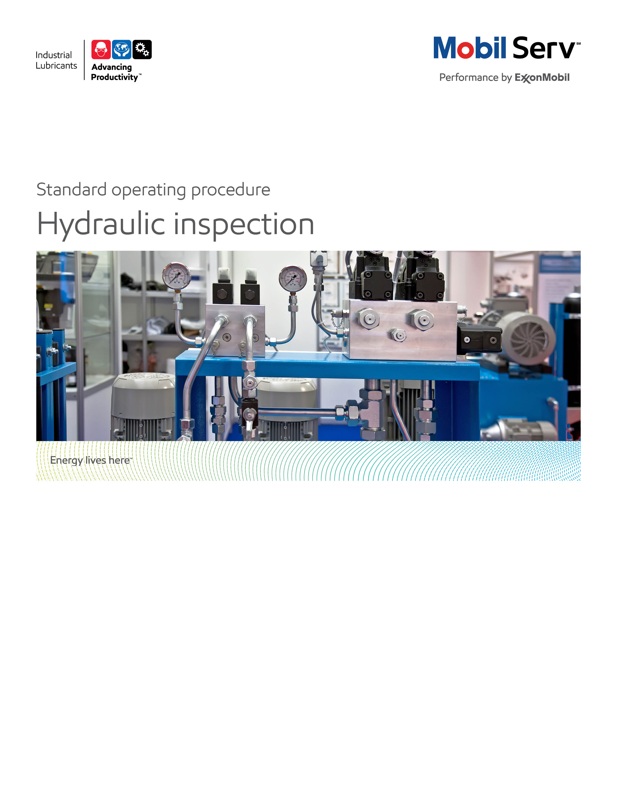

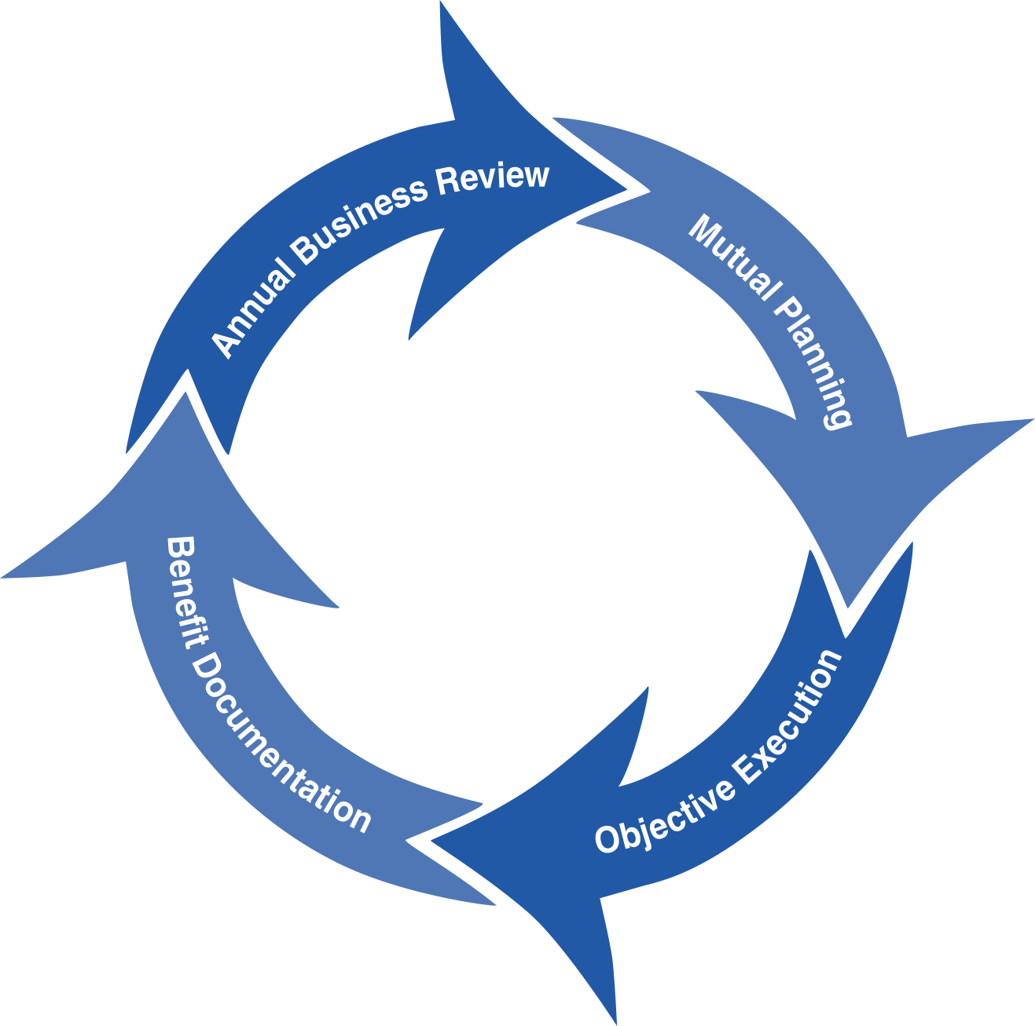
Standard Operating Procedure (SOP)
Read all of the steps in this SOP before beginning work. Follow customer labor requirements (eg respect Union work)

SOP: Hydraulic System Inspection, Stationary Equipment |  | DATE  1/21/2011  03/11/16 |  NEW  o REVISED  ___ Number |  | PAGE 1 of 3
TYPICAL CUSTOMERS  Pulp & Paper, Plastics, Gen Mfg | WORK TYPE  Hydraulic System Inspection | WORK ACTIVITY (Description)  Oil Sampling, Temperature, Leak, & Noise Checks, Filter and Breather Inspections
DEVELOPMENT TEAM | POSITION / TITLE | REVIEWED BY/DATE |  | POSITION / TITLE
John Burtsche | Sr. Lube Engineer | Bill Fuller 1/20/2011 |  | FES Advisor
Andy Lyczak | Sr. Lube Engineer | Tom Schiff 1/21/2011 |  | FES Manager
Bill Brandt | Sr. Lube Engineer
PLEASE UTLIZE ATTCHED GENERAL JSA AS GUIDANCE AND, IF YOU HAVE DONE A SITE SPECIFIC JSA.
PLEASE ASSESS YOUR OWN CONDITIONS OR SPECIFIC SAFETY REQUIRMENTS AND BE SAFE. http://intratta.na.xom.com/emdn/sbps/docs/safety/jsa/JSA_Hydraulic_System_Inspection_Stationary_Equipment.xls
EQUIPMENT INDEPENDENT OF JSA DESIRED DOCUMENTATION
 CLIPBOARD OR TABLET PC  CRESCENT WRENCH   IR GUN or SEEK THERMAL UNIT  SCREWDRIVER'S   FLASHLIGHT  ELEC. BLACK TAPE   SAMPLE THIEF, BOTTLES & LABELS  OIL LEAK CARD   RAGS   CAMERA  CHECK WITH CUSTOMER : OK TO USE OWN TOOLS OR MUST BE CUSTOMERS |  |  DAY OF - ENGINEERING SERVICE NOTICE (ESN) AS LEAVE BEHIND   FINAL - ENGINEERING SERVICE REPORT (ESR) WITH TOTAL COST of OWNERSHIP (TCO) SAVINGS & MOBIL SERV REPORTS  OTHER (SPECIFY)   HYDRAULIC SYSTEM INSPECTION CHECKLIST   PRIOR INSPECTION CHECKLISTS TO REVIEW TEMP PLOTS & CONDITIONS   TCO - HYDRAULIC SAVINGS
TIME ESTIMATED TO COMPLETE THIS TASK NUMBER OF PEOPLE TO PERFORM THIS TASK
10 - 20 MINUTES PER HYDRAULIC POWER UNIT |  | 1 -2 LE, + SE, or DSR
FREQUENCY TO PERFORM THIS TASK SKLLS REQUIREED TO PERFORM THIS TASK
DEPENDS ON PES or MAJOR, SGA, OR INA ACCOUNT CUSTOMER COMMITMENT, USUALLY 1 -2 TIMES PER YEAR FOR HYDRAULIC POWER UNIT |  |  MECHANICAL APPTITUDE   HYDRAULIC PRINCIPLES (LUBRICATION FUNDAMENTALS, 2ND EDTION, PIRRO & WESSOL, CHAP 7 "HYDRAULICS")   LISTEN FOR SYSTEM ABNORMAL NOISE; CAVITATION, AERATION   OBSERVE AND COUNT OIL LEAKAGE; DROPS PER SECONDS & CONVERT TO GALLONS.
JOB COMPETANCIES REQUIRED TO PERFORM THIS TASK, |  | TRAINING REQUIRED TO PERFORM THIS TASK
PRODUCT SELECTION - HYDRAULIC OILS.  OFFER EXECUTION - BASIC OFFER EXECUTION - INSPECTIONS - HYDRAULICS.  INDUSTRIES - PLASTICS & GENERAL MANUFACTURING  APPLICATIONS - HYDRAULICS. |  |  lms - PRODUCTS - HYDRAULICS, eLEARN   lms - HYDRAULICS, BUSINESS & TECHNICAL eLEARN   lms - PLASTICS, BUSINESS & TECHNICAL eLEARN   HYDRAULIC SYSTEM INSPECTION OUTLINE.PPT (ATTACHED)   VIEW VIDEO ON CAVITATION (INSIDE SALES INDUSTRIAL GBU - TECHNICAL)   VICKERS HYDRAULICS SCHOOL

PURPOSE - To describe the process of conducting a Hydraulic System Inspection while the equipment is in operation (Dynamic), with the desired reporting that provides the value back to the customer.

LOCATION | JOB STEPS
Production Area for Equipment to be Inspected | - Notify operator of machine that you are in the area conducting the inspection on the hydraulic system.
Hydraulic System Inspection  Use HSI Worksheet | Visually inspect system for:  - Leakage at any fitting  - Reservoir level, and oil color, temperature, and general condition  - Pressure Gauges Greater than 25 psi between upstream/downstream, indicates filters needing changed)  - Check air breathers filters and oil filter housings  - Hoses – rubs, wear, kinks, or movement  - Operation - jerky or erratic
Listen to hydraulic system operation:
- Surge - water hammer
- Marbles - Cavitation
- Shrill Whine - cavitation with back pressure
- Aeration - high pitched sound
System Temperature Check with IR Temperature Gun:
- Reservoir temperature: > 150 F hot, <110 F cold
- Motor temperatures: >100F above ambient hot
- Pump temperatures: < 150F is optimal
- Valve temperatures: < 170F is optimal
- Motor temperatures: <130F is optimal
- Heat exchangers (at least a delta of 10F between in/out same fluid is optimal)
- Place black electrical tape onto surfaces to check for temperature (controls emissivity and location for consistency and accuracy)
- Trend periodically to show changes from prior inspections
Hydraulic System Sample | - Clean area around sample point location  - Use clean sample bottles  - Use clean sample thief and hose  - Take representative sample from the reservoir. This involves purging into a sample bottle, then putting a new sample bottle in the pump and purging two samples before drawing the representative sample.  - Visually inspect sample for water, sediment and color  - Clean any spilled lubricant or debris  - Secure sample point after sampling  - Conduct filter patch test if contamination observed  - Have customer submit other samples to Mobil Serv
Storage and Dispensing Containers | - Observe types of containers for proper oil label  - Observe types of containers for preventing ingression of contaminants (are they sealed)  - Are containers dedicated by product, well labeled?  - General note on housekeeping of containers
Feedback about this SOP - Send to Field Engineering Advisor/Supervisor | .

DOCUMENTING YOUR WORK - The Hydraulic System Inspection is used to verify the performance of Mobil premium and flagship hydraulic oils. The Hydraulic System Inspection Worksheet can be used as a guide to assist in the inspection and preparing an Engineering Service Notice or Engineering Service Report. Proper placement is in an Appendix. TCO calculations that may apply are: Expenditures Reduction, Process Improvement, Revenue Enhancement and Asset Improvement as detailed below. The TCO Worksheets are the preferred format to include in your report. Proper placement is in an Appendix. Additional guidance will incorporate our messaging of TCO to include Sustainability, Safety and Productivity relationships via 3d Writer.

Expenditure Reduction - reduced lubricant purchase costs are the most typical expenditure savings. These only result from the offset of extending lube application intervals from the previous lube against the increased price of Mobil DTE 20/ Mobil DTE 10 Excel/ Mobil SHC 500's (or premium and flagship) products. Expenditures could also be the cost of pump replacement ($3,000 good average cost for 15-30 gpm pumps), hydraulic system change outs, valves, motors and other hydraulic components. This may allow the customer to plan for a replacement during a planned outage instead of an emergency shutdown. A third expenditure may come from disposal costs of used hydraulic oil. Find out how much the unit cost of disposal is and use the consumption on an annual basis. Make sure to factor in the reduced usage with Mobil DTE 20/ Mobil DTE 10 Excel/ Mobil SHC 500's (or premium and flagship) products as they apply or have applied in time.

Process Improvement - the hourly wages (including burden) for personnel to perform existing tasks. If pump replacements or lubricant change outs are reduced, use these to determine Process improvements. If lubricant usage is reduced, use the time to handle drums and the time to dispose of used lube to determine Process improvements.

Revenue Enhancement - any serious abnormal hydraulic system or lubricant condition observed may be repaired during normal maintenance and reduce the potential for downtime. “Unscheduled Downtime”, resulting in lost production and most often, scrapped parts or material. Ask the customer what the cost of lost production (idle machinery, personnel, etc.) is.

Asset Improvement - use the customers "cost to carry" (usually 20%) inventories. This is used from the Expenditures components for example, if you reduce the quantity of lube needed, take that amount cost and multiply by the "cost to carry" to determine the Asset value.

Refer to Expenditure Reduction, Process Improvement, Revenue Enhancement, Asset Improvement and TCO Summary Worksheet.xls.

Documentation Links:
Model ESR http://intratta.na.xom.com/emdn/sbps/technical/model_doc/esr/Sector_Type/General_Manufacturing/Hydraulic_Inspection_Gen_Manu_Example_1.pdf

HSI Worksheet TCO Worksheets

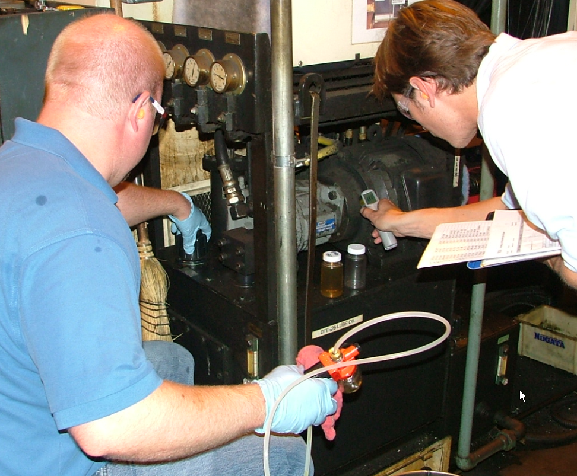
Execution: Team using proper tools and equipment
Safety: Team wearing proper PPE

Industrial Sales Engineer/Territory Manager and Industrial Lubrication Engineer/Field Engineer Team Conducting a Hydraulics System Inspection

